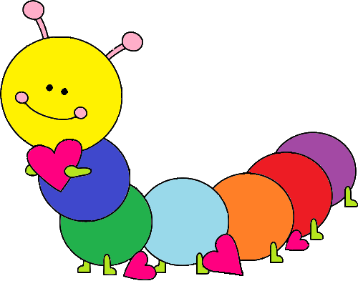

Welcome to Caterpillars
This half term we are encouraging children to settle into and explore the Caterpillars environment and supporting them to make relationships with their key person and other children. We are introducing Maisy Mouse stories relating to everyday activities children might engage in.
Our topic is called:
‘Me and my family’
In this topic children are encouraged and supported to:-
Get to know routines and expectations of Caterpillars room e.g. what happens each session, where things are kept, to put toys away and to play safely in the environment.
Join in and play with Key person and other adults and children in nursery.

Be increasingly independent in personal care such as dressing/undressing, feeding/drinking, toileting and hand washing, tidying and pouring their own drink.



Make family photo boards to share and talk about in nursery.

Take part in home role playing using ‘Maisy Mouse’ books, as well as home experiences to stimulate and model play and develop sharing skills.

Find out and explore all the nursery areas inside & out, and talk about what they like to do.

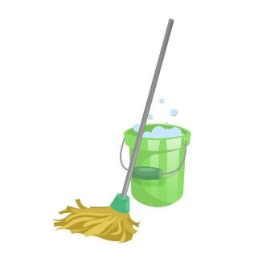

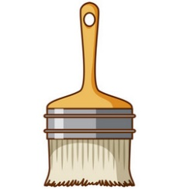

Explore equipment that encourages them to move with gross motor movements, developing control and confidence.
Choose their favourite rhymes and join in with words and actions.

These are some of the books we will be reading with the children this half term
- Maisy goes to Nursery
- Maisy Tidies Up
- Maisy Dresses Up

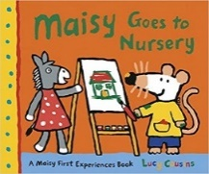

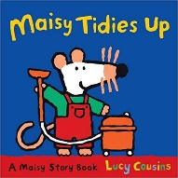
From this we will observe children’s interests and particular skills which will inform the next stage of our planning. We can then prepare more fun activities to introduce next to capture their interest and develop their learning!

