Welcome to Butterflies!!
We hope you have had a fabulous summer break.
We will start this half term with encouraging children to settle into and explore the Butterflies environment, and to make relationships with their key person and other children. In addition, we are encouraging children to be confident to talk about themselves and their families. Our topic is called:
‘The one and only special me!’
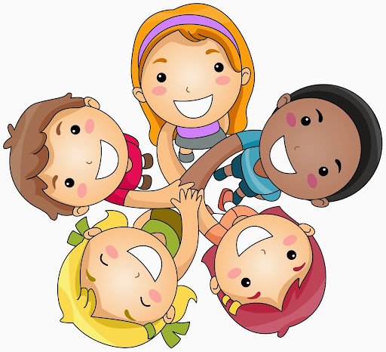
In this topic children are encouraged and supported to:-
Get to know routines and expectations of Butterflies Pre-school e.g. what happens each session, where things are kept, to put toys away and to play safely in the environment.

Explore and find out all the areas in Butterflies class, both inside and out in the garden. Talk about what they like to do.





Listen to and talk about stories around family members and special days such as birthdays.
We will use books, rhymes and play to motivate children to talk about what and who is special to them at home.

Count and talk about numbers in relation to themselves, such as how many people in their family, candles on the birthday cake as well as objects and numbers in the environment. Children will count props and solve problems with number in number rhymes.

Take part in role playing and talking about their own birthday celebration. Recognise similarities and differences between themselves and others.

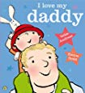
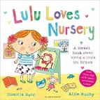
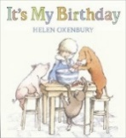
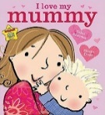
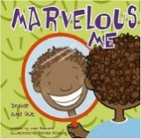
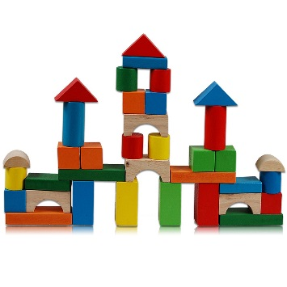
As we get to know the children we will observe and take note of what their particular interests are and their favourite things to do. This will help us prepare what fun activities we follow on with for the next stage in their learning!
These are some of the books we will be reading with the children this half term to help motivate talk and activities about themselves and others
- Nursery
- Lulu loves Nursery
- The One and Only Special Me
- Marvellous Me
- I love my Mummy
- I love my Daddy
- Smart Aunties
- All Kinds of People
- It’s My Birthday
- Kipper’s Party
Talk about self and family as well as people who are special to them. Your child’s Key Person will provide card and materials if you would like to make a photo album at home with them. These books will then be put in the book corner for children to share regularly.

