Portsdown Primary School Handwriting Policy

“Handwriting is a tool that has to work. It must be comfortable, fast and legible.”
(Angela Webb, Chair, National Handwriting Association)

Aim:
The aim of this policy is to provide a clear and consistent approach to handwriting so that every child is supported to develop this key life skill. Our aim is that children will be able to write fluently and with ease so that their energy can be focused on the content of what they want to write and not the act of physically writing.
Handwriting is a skill which, like reading and spelling, affects written communication across the curriculum. Children must be able to write with ease, speed and legibility. Handwriting skills are taught regularly and systematically throughout the school.

The key advantages to this are:
• By making each letter in one movement, children’s hands develop a ‘physical memory’ of it, making it easier to produce the correct shape
• Because letters and words flow from left to right, children are less likely to reverse letters which are typically difficult (like b/d or p/q)
• There is a clearer distinction between capital letters and lower case.
• The continuous flow of writing ultimately improves speed and spelling which prepares them for the demands of the Key Stage 2 curriculum.

We aim for children to:
- Achieve a neat, legible style with correctly formed letters
- Develop flow and speed to aid expressing themselves creatively and imaginatively across the curriculum and for a range of purposes
- To automatically use clearly formed handwriting in all of their writing
- Use their skills with confidence, in real life situations

Teaching and Learning - Implementation
The following principles are followed:

- Patterns relating to letter formations are first introduced using a variety of tools and multi-sensory methods. This develops free flowing hand movements and muscle strength. Letters are also introduced in varied, multi- sensory sessions such as: writing letters in the air, on backs or hands; orally describing letter shapes and joins with children using ‘letter speak’; using a variety of writing materials including whiteboards, chalk, paints, felt pens, crayons, plasticine, cornflour mix, shaving foam etc.
- It is taught regularly through short, focused sessions and may be linked with spelling, grammar or phonics objectives. Teacher modelling of handwriting occurs throughout the school day so that children become very familiar with handwritten script.
- Handwriting is practised in the children’s English book or on paper with the same size lines.
- Correct pencil hold and letter formation are taught from the beginning and handwriting is frequently linked with spelling. We use the four ‘P Checks’ as recommended by the National Handwriting Association:
- When marking or writing comments, members of staff use handwriting as appropriate for the year group.
- Teachers model appropriate script for their children when writing.
- Displays around the school and classroom should model age appropriate handwriting as well as other fonts.
- Older children, especially those joining the school, will not be expected to adopt the cursive joined style if they already have a fluent, legible handwriting style.

Handwriting Progression –
This progression outlines what is expected for most children in each year group. There may be some children who require additional support of resources and need this progression to be adapted for them.

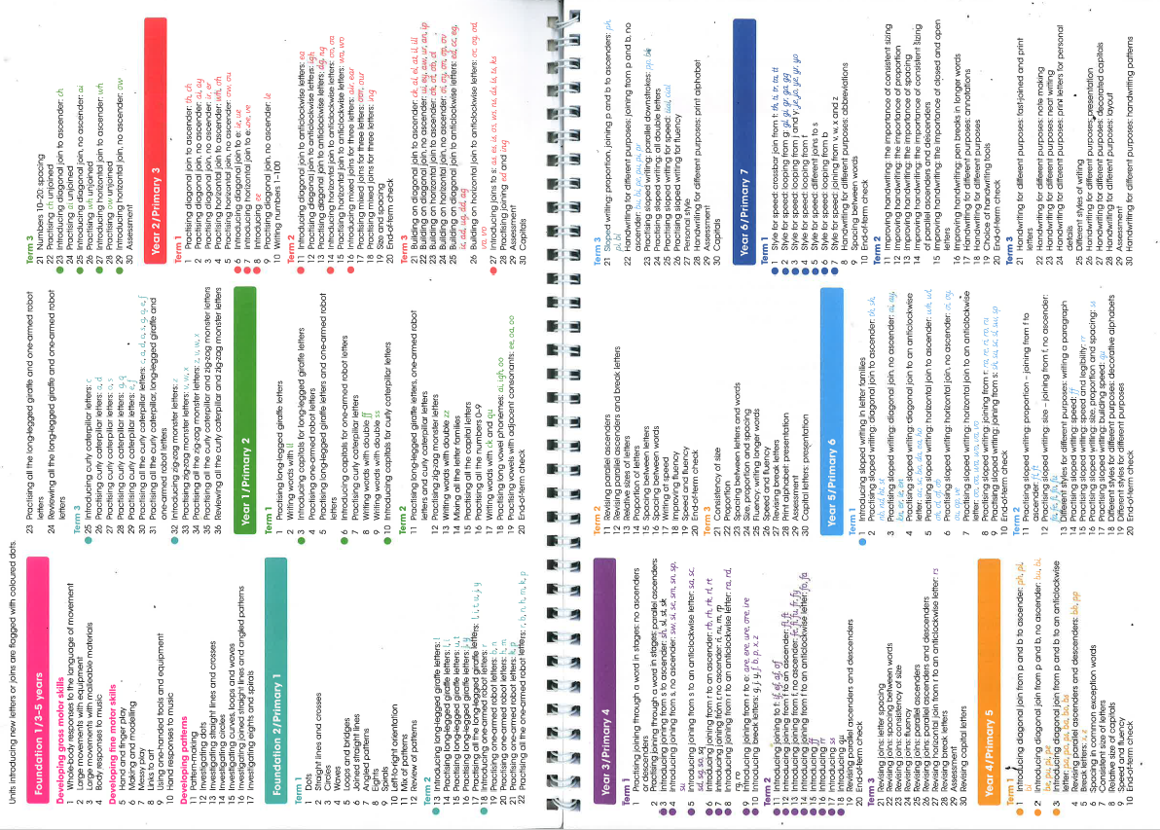

This progression outlines what is expected for most children in each year group. There may be some children who require additional support of resources and need this progression to be adapted for them.
Progression in Handwriting – National Curriculum:
Year 1
- Sit correctly at table, holding a pencil comfortably and correctly
- Begin to form lower-case letters in eh correct direction, starting and finishing in the right place
- Form capital letters
- Form digits 0-9
- Understand which letters belong to which handwriting ‘families’ and to practise these
- Year 2
- Form lower-case letters of the correct size relative to one another
- Start using some of the diagonal and horizontal strokes needed to join letters and understand which letters, when adjacent to one another, are best left unjoined
- Write capital letters and digits of the correct size, orientation and relationship to one another and to lower-case letters
- Use spacing between words that reflect the size of the letters
- Year 3-4
- Use the diagonal and horizontal strokes that are needed to join letters and understand which letters, when adjacent to one another are best left unjoined
- Increase legibility, consistency and quality of their handwriting
- Year 5-6
- Write legibly, fluently and with increasing speed by:
- -choosing which shape of a letter to sue when given choices and deciding, as part of their personal style, whether or not to join specific letters
- Choosing the writing implement that is best suited for a task

Techniques for teaching letter formation and joins:
- Always model good handwriting
- Demonstrate formations
- Talk through the process – model yourself as the writer
- Encourage children to verbalise the process
- Children form letters in the air and on parts of the body
- Modelling the anticlockwise actions
- Finger trace over tactile letters
- Write in sand with finger or a stick
Basic structure of a handwriting session:
- Gross and fine movement warm up
- Posture check: feet flat on the floor, back straight and touching the chair
- Teacher modelling
- Children practising independently with a teacher model, then from memory
The phonics sessions in Foundation Stage and Key Stage 1, provide opportunities to reinforce and correct handwriting. In Year R, children use the Little Wandle letter formation rhymes to support the letter writing. Children then build on this using the Pen Pals Scheme. It is important that incorrect formation and orientation is picked up and correctly modelled by all adults to make sure that children are not allowed to keep repeating, and therefore overlearning, errors.

We use the S factors for success from The National Handwriting Association to support our teaching of handwriting throughout the school.

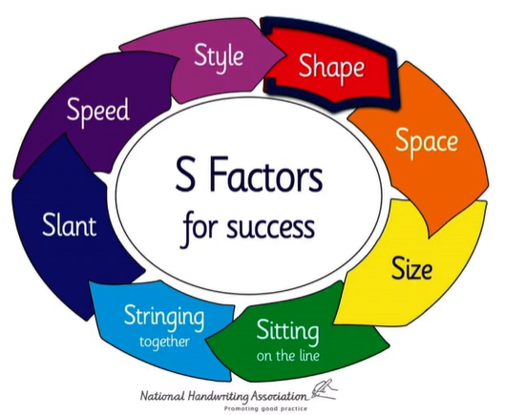
Handwriting equipment
Children need to have a range of equipment available to support the writing process. Pencils are most frequently used in Key Stage 1 and we also make use of whiteboard and pens. If children find putting the pressure down on the page there are some weighted pencils available and pens can be an option to make the writing easier to read.
In school we also have pens and pencils with grips to support those children that may find holding writing equipment difficult.

Appendix:
The following ‘letter families’ illustrate the order in which letters should be taught to children. They are grouped into similar shapes to enable children to practice and consolidate similar shapes together.

